**Search Filters**

Steps:

1. Go to AEM welcome page.

<http://localhost:4502/aem/start.html>

1. Click on sites -> Hit back slash button

We should be able to see a screen like shown below.

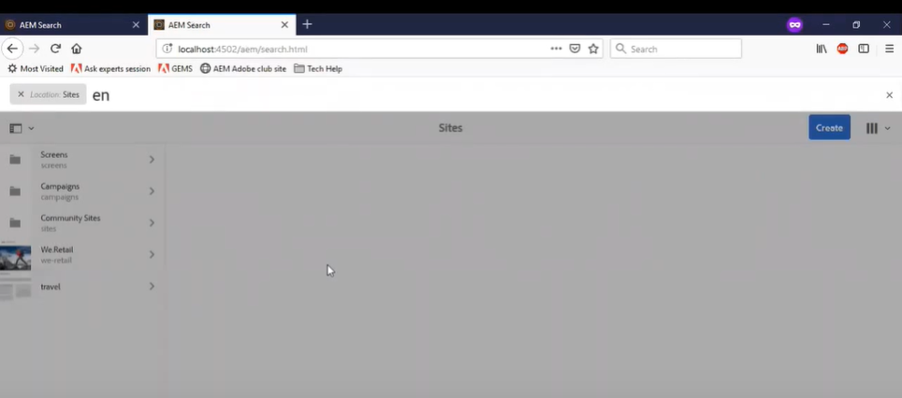

1. Enter the search term (in this case it is “en”) and we should be able to see the search results (if present) and an option to export these results to a file (**“CSV report”**).

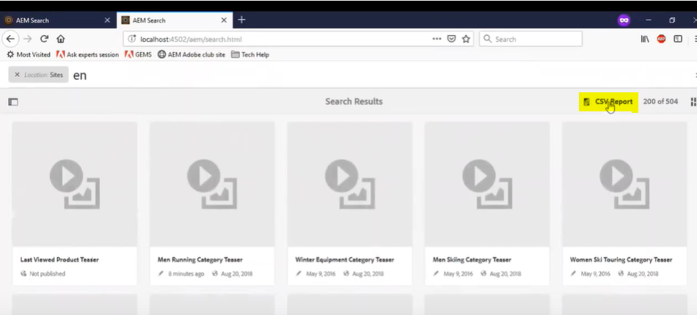

On click of CSV report, it would show a screen like shown below, giving an option to select the information that we want to export to the file.

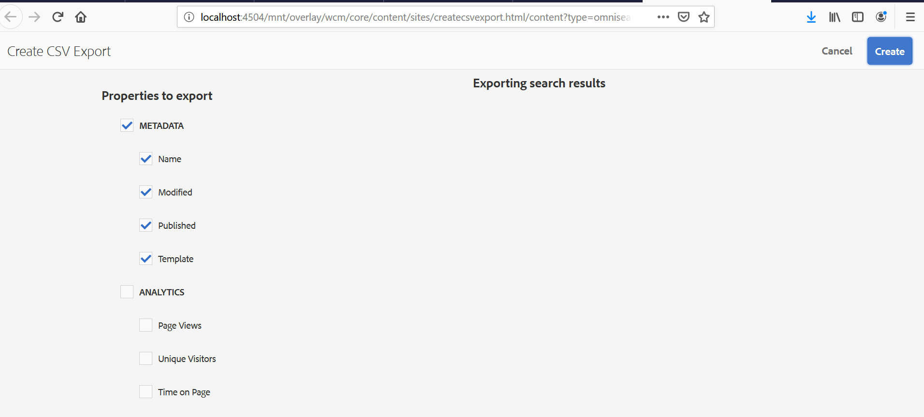

As we have selected only first 4, only these values will be exported to the final csv file.

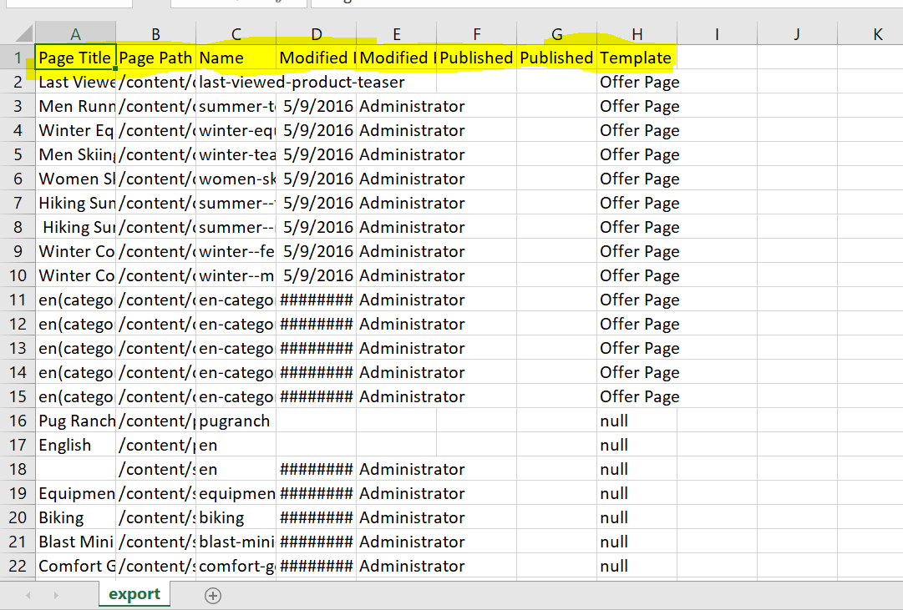

**Other options to explore.**

1. We have an option to save the search criteria, so that we can select it to retrieve the results for this saved search criteria later.

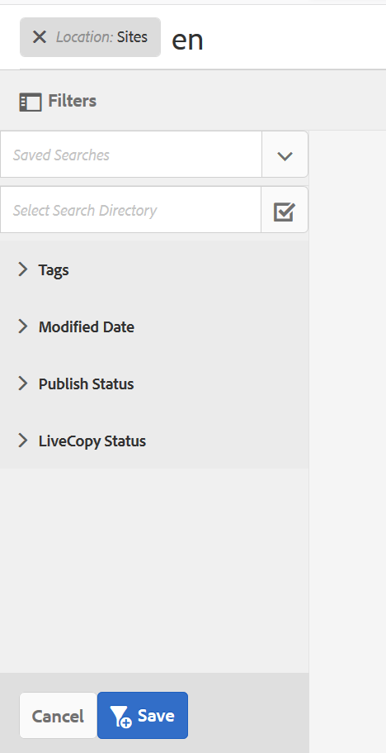

As we can see here, after searching for the keyword “en”, the results would get displayed on the right side, but on the left panel we have an option to save the search criteria.

Provide the name before we proceed to save the results.

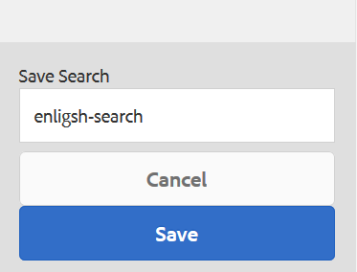

Click on “save” button to save the search criteria. After successfully saving the results, we would see a success message like the one shown below.

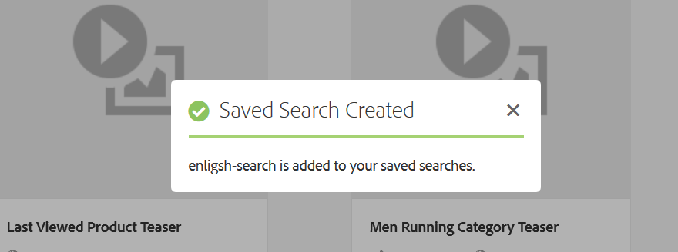

After saving the changes, we can see the saved search values in the dropdown as shown below.

